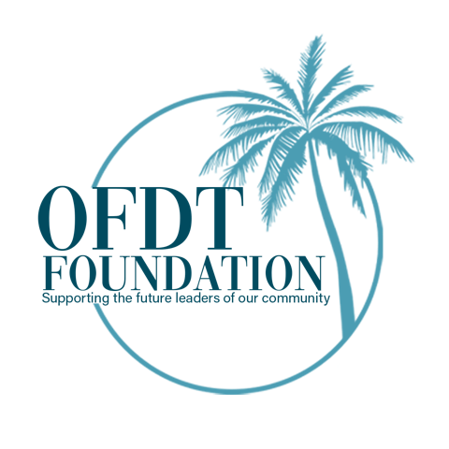
The OFDT Foundation Support Application
Once completed please email to: info@OFDTFoundation.com

Personal Information
NAME ___________________________________________________
PREFERRED NAME ___________________________________________________
HOME ADDRESS ___________________________________________________
___________________________________________________

TELEPHONE ___________________________________________________
EMAIL ___________________________________________________
DATE OF BIRTH ___________________________________________________
CURRENT SCHOOL ___________________________________________________
ADDRESS ___________________________________________________
TELEPHONE ___________________________________________________
DATE OF GRADUATION ___________________________________________________
NAME OF HIGH SCHOOL ___________________________________________________
COUNSELOR ___________________________________________________
CURRENT REQUEST/NEED ___________________________________________________
___________________________________________________
___________________________________________________
___________________________________________________

REASON FOR REQUEST ___________________________________________________
___________________________________________________
___________________________________________________
___________________________________________________

TOTAL AMOUNT REQUESTED: _______________________________________________

The Old Florida Dream Team Foundation was founded to assist students in the Southwest Florida area. The specific goal is to underscore expenses associated with school related and personal needs and provide opportunities for middle and high school students. Old Florida Dream Team Real Estate will contribute a portion of all sales to the Foundation and give their clients an opportunity to match the donation. The foundation will provide money directly to students through schools and other support organizations for things like prom, college applications, mentors, college visits, and so much more. Each application will be carefully screened and answered within 48 hours.

